1) Create a table named "students" with the following columns:

* + id (integer, auto-increment, primary key)
  + first_name (text)
  + last_name (text)
  + age (integer)
  + email (text)

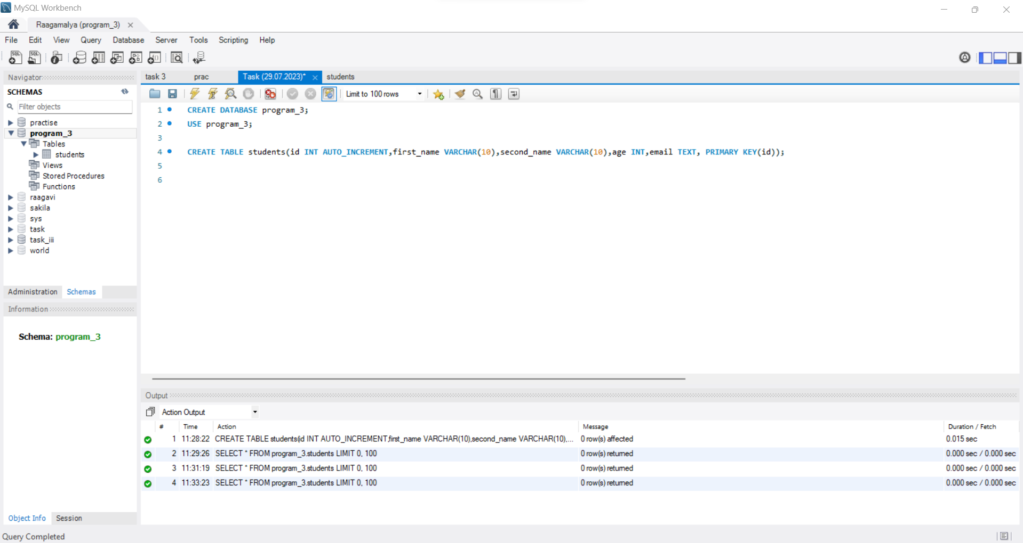

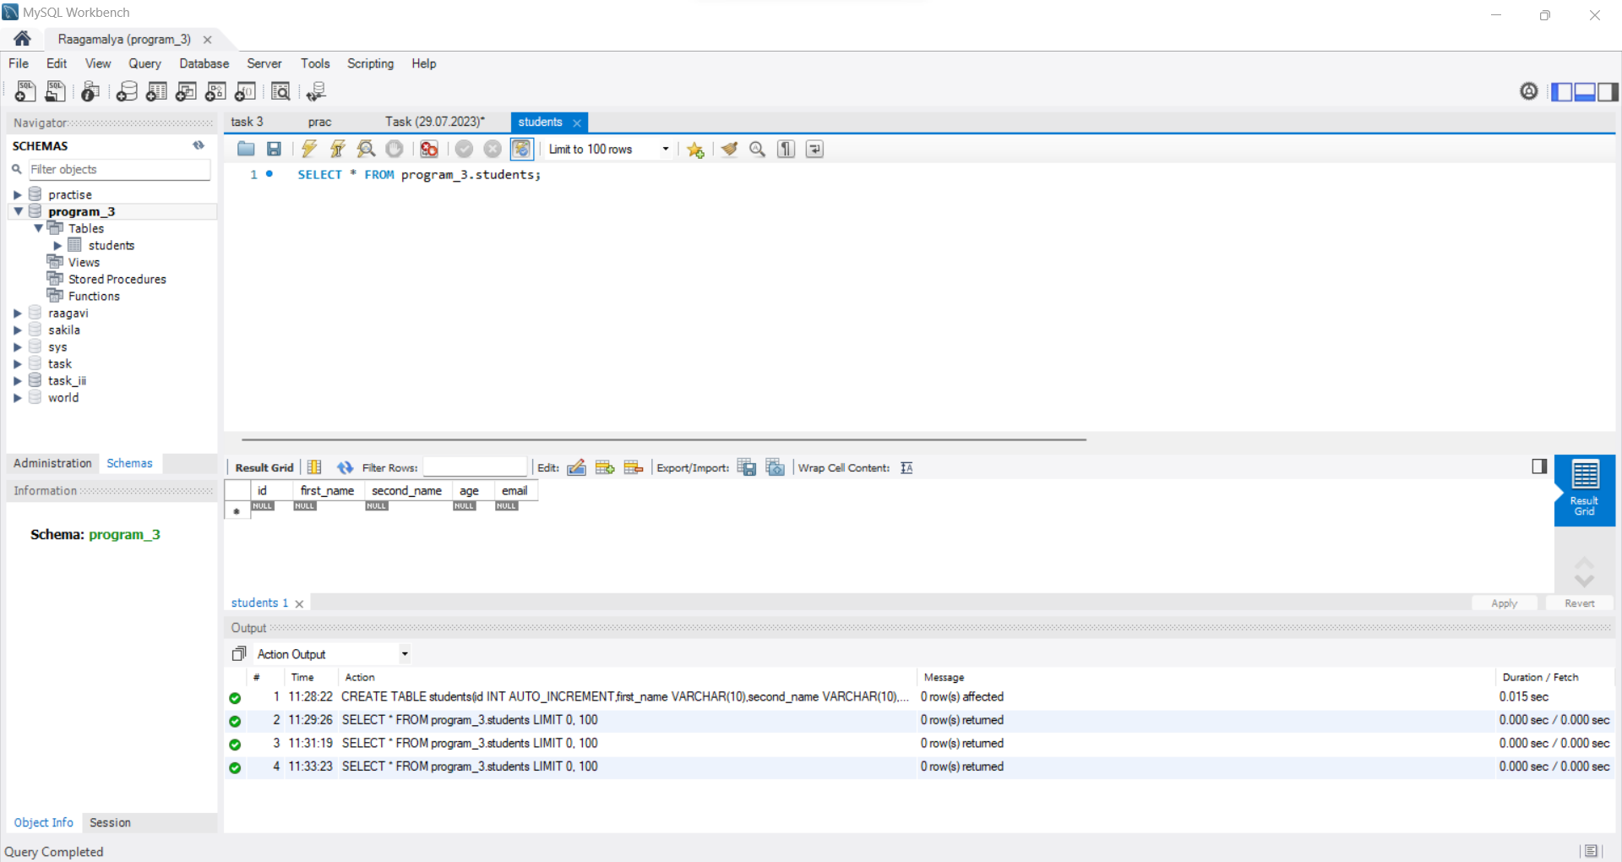

2) Insert five sample records into the "students" table.

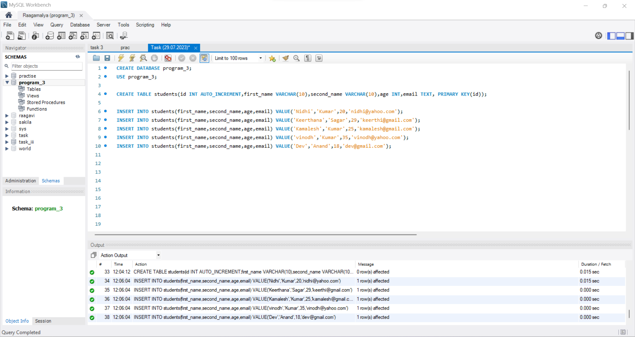

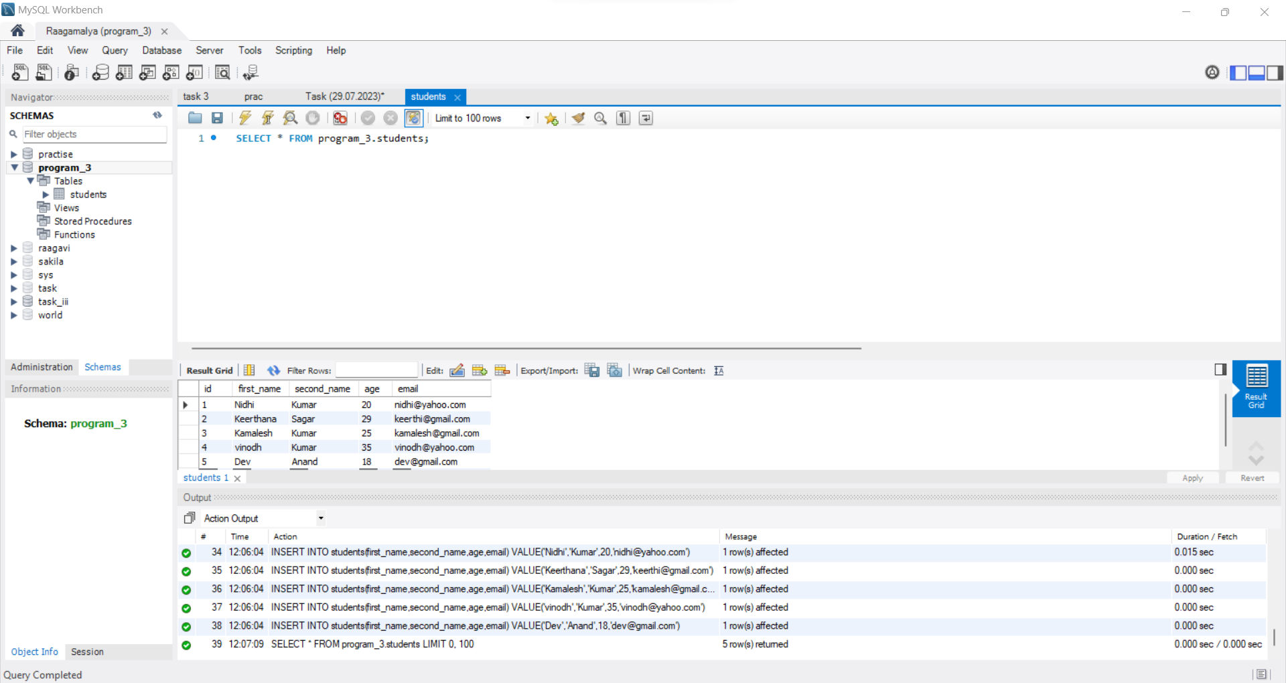

3) Write a query to retrieve all students from the "students" table.

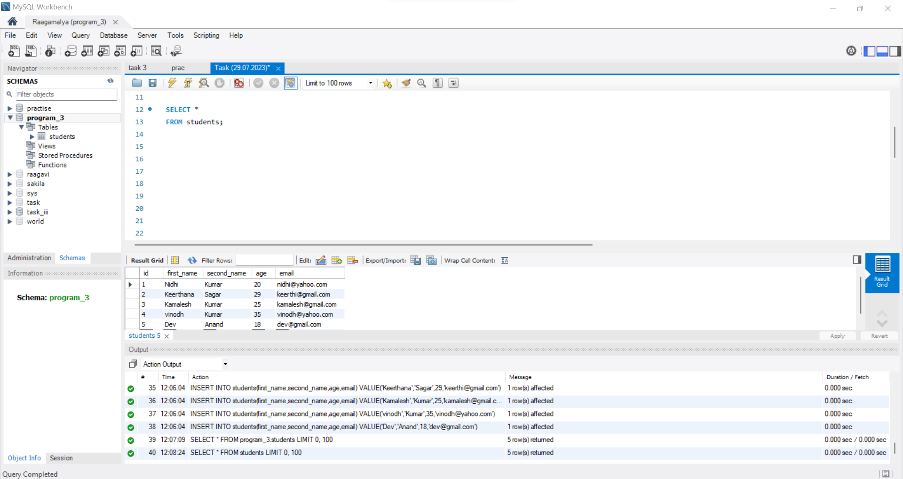

4) Write a query to retrieve students who are aged 20 or above.

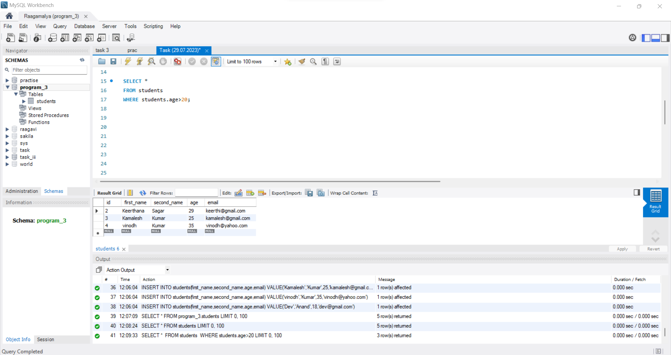

5) Write a query to retrieve students who have "gmail.com" in their email addresses.

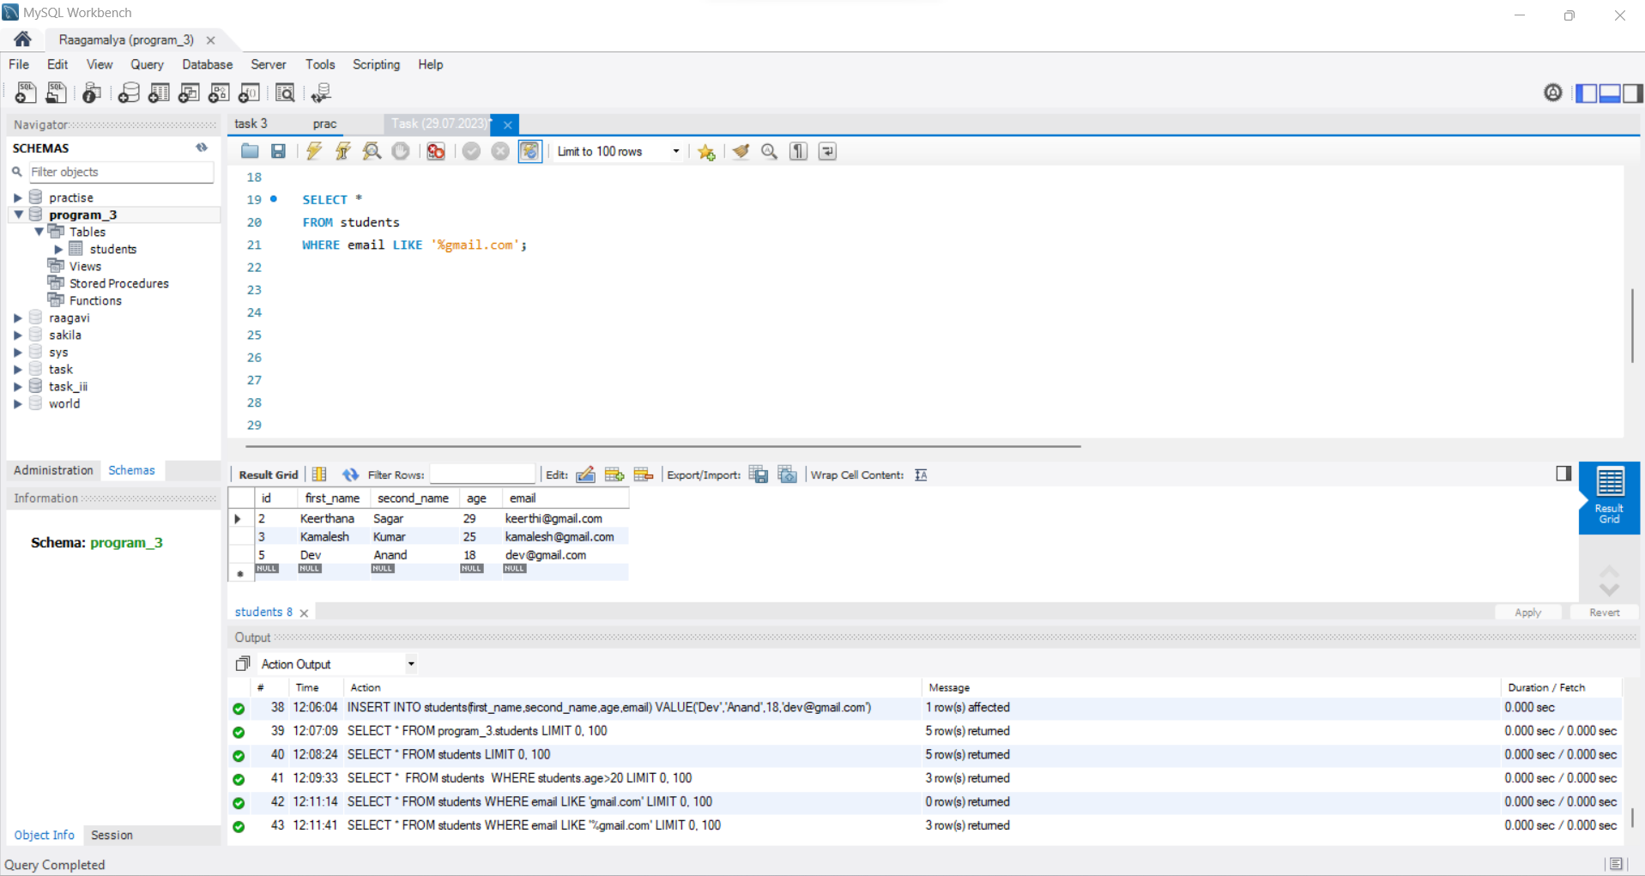

6) Write a query to retrieve the youngest student from the "students" table.

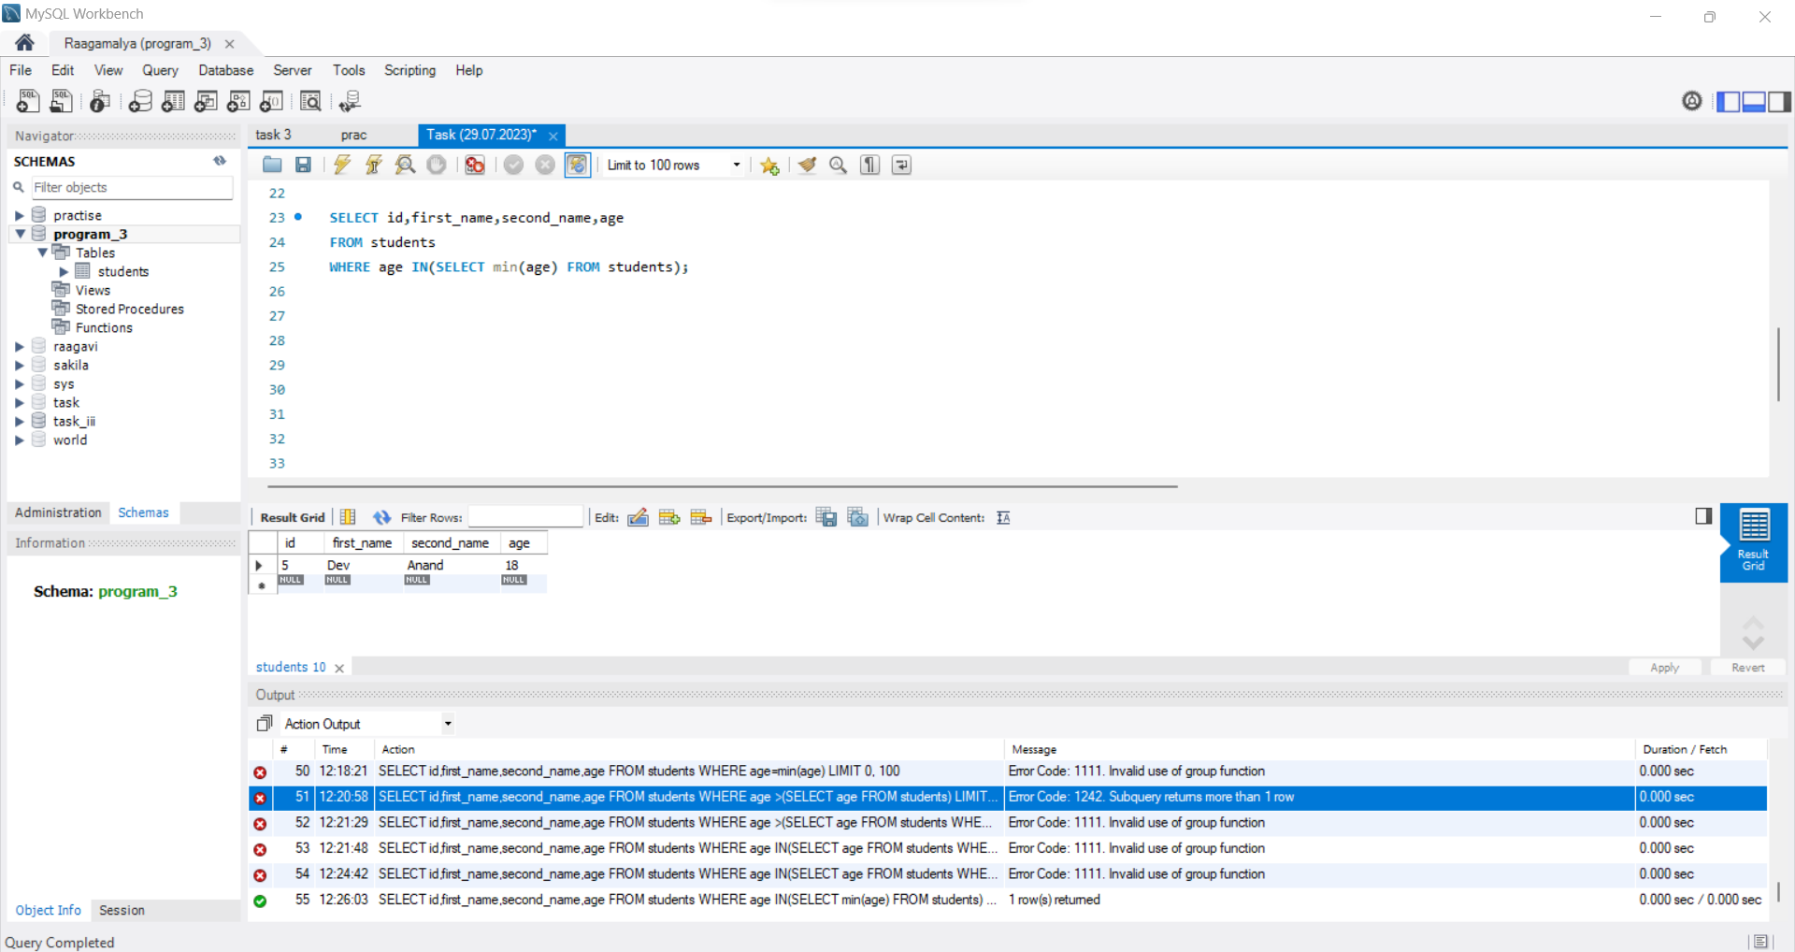

7) Write a query to calculate the average age of all students.

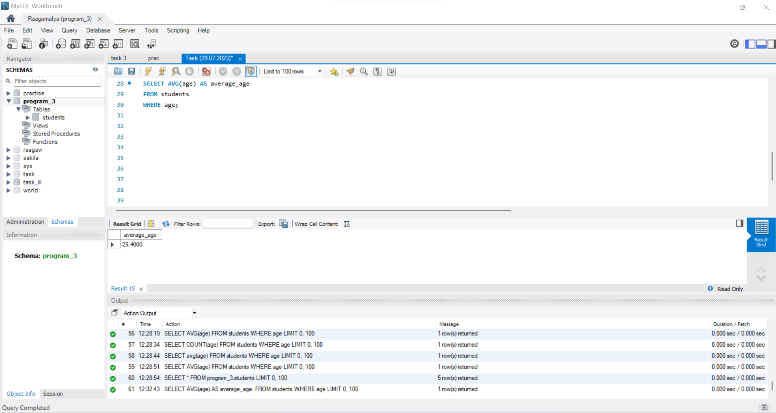

8) Create a table named "courses" with the following columns:

* + id (integer, auto-increment, primary key)
  + course_name (text)
  + instructor (text)

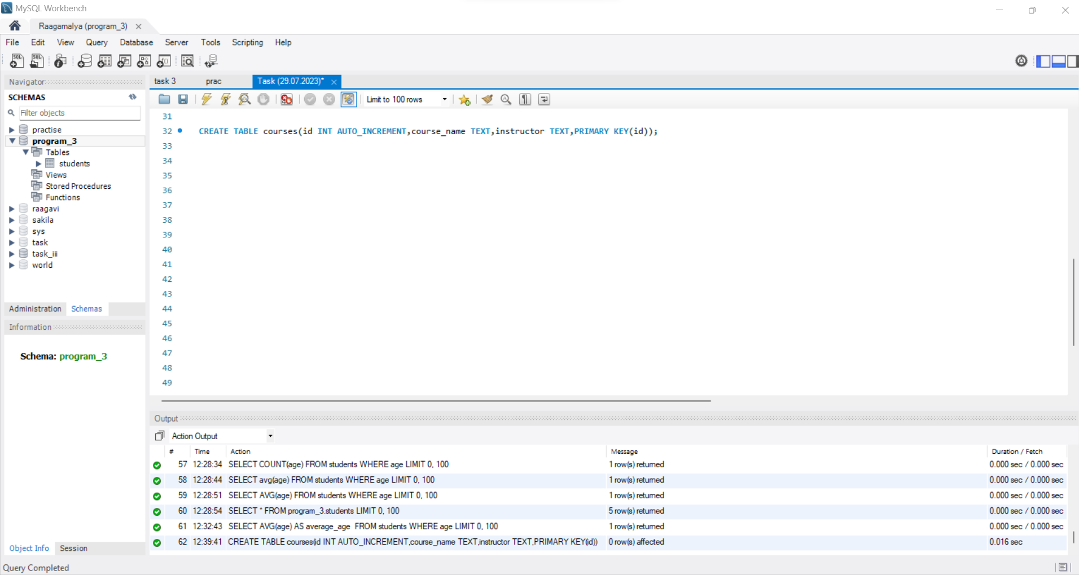

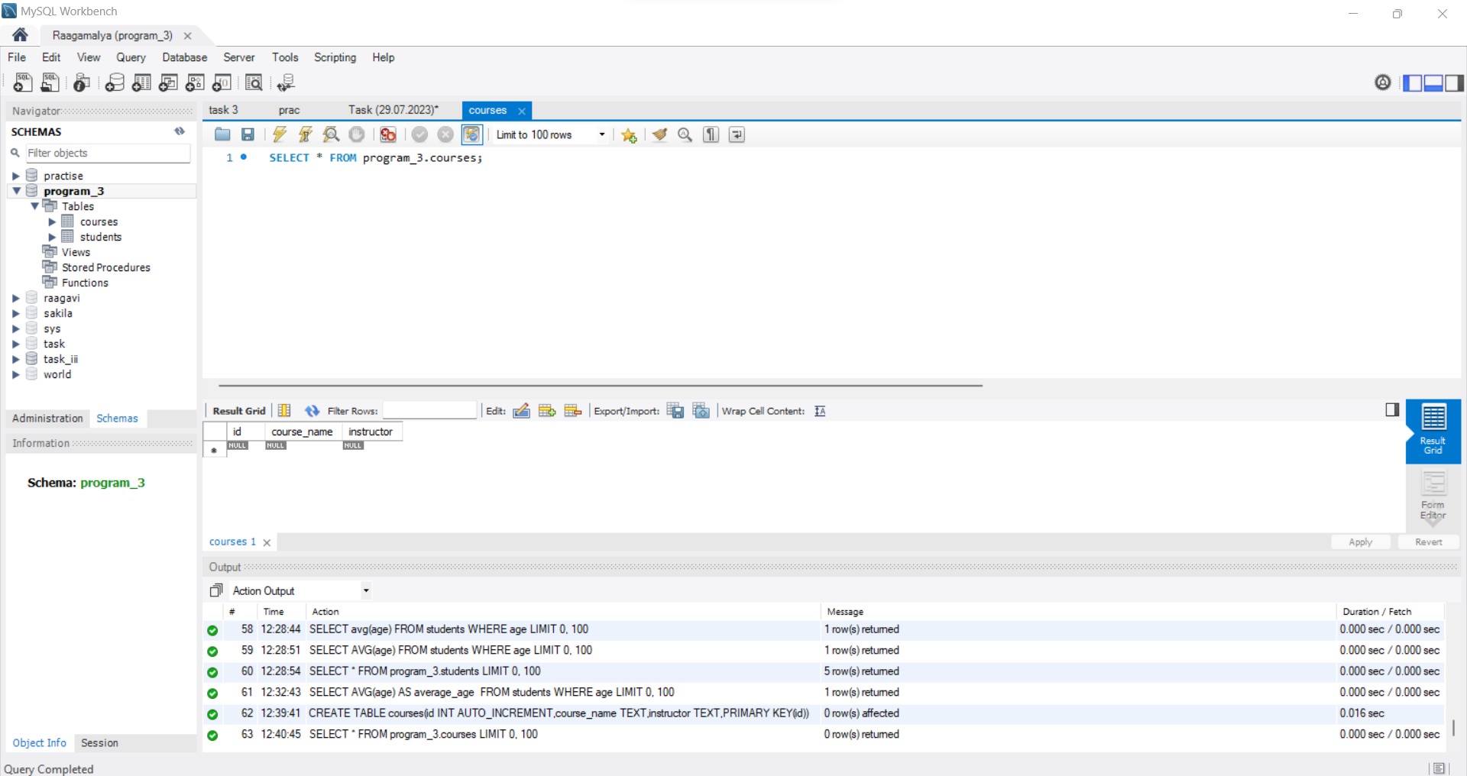

9) Insert three sample records into the "courses" table.

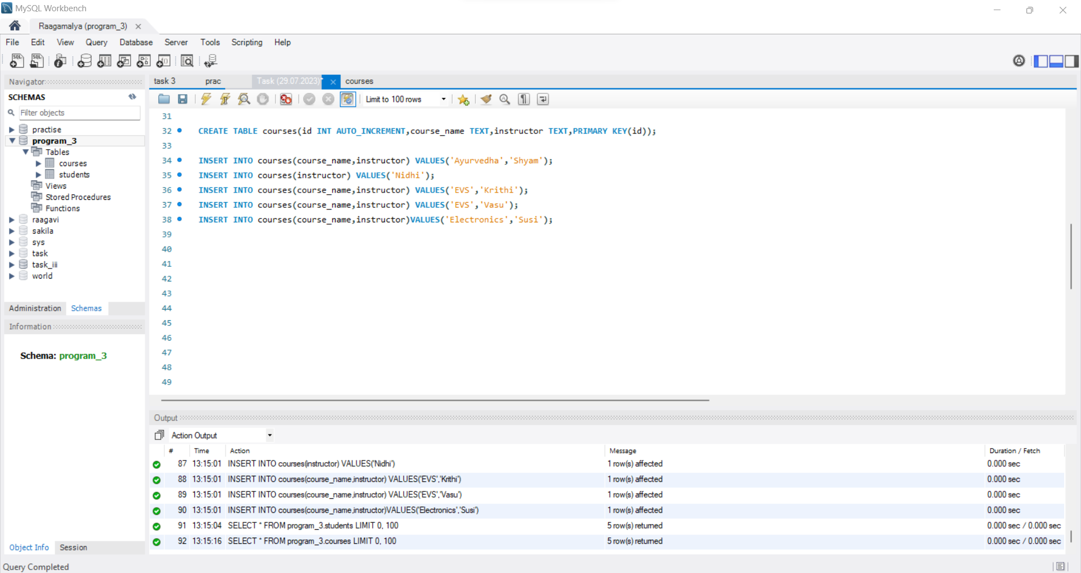

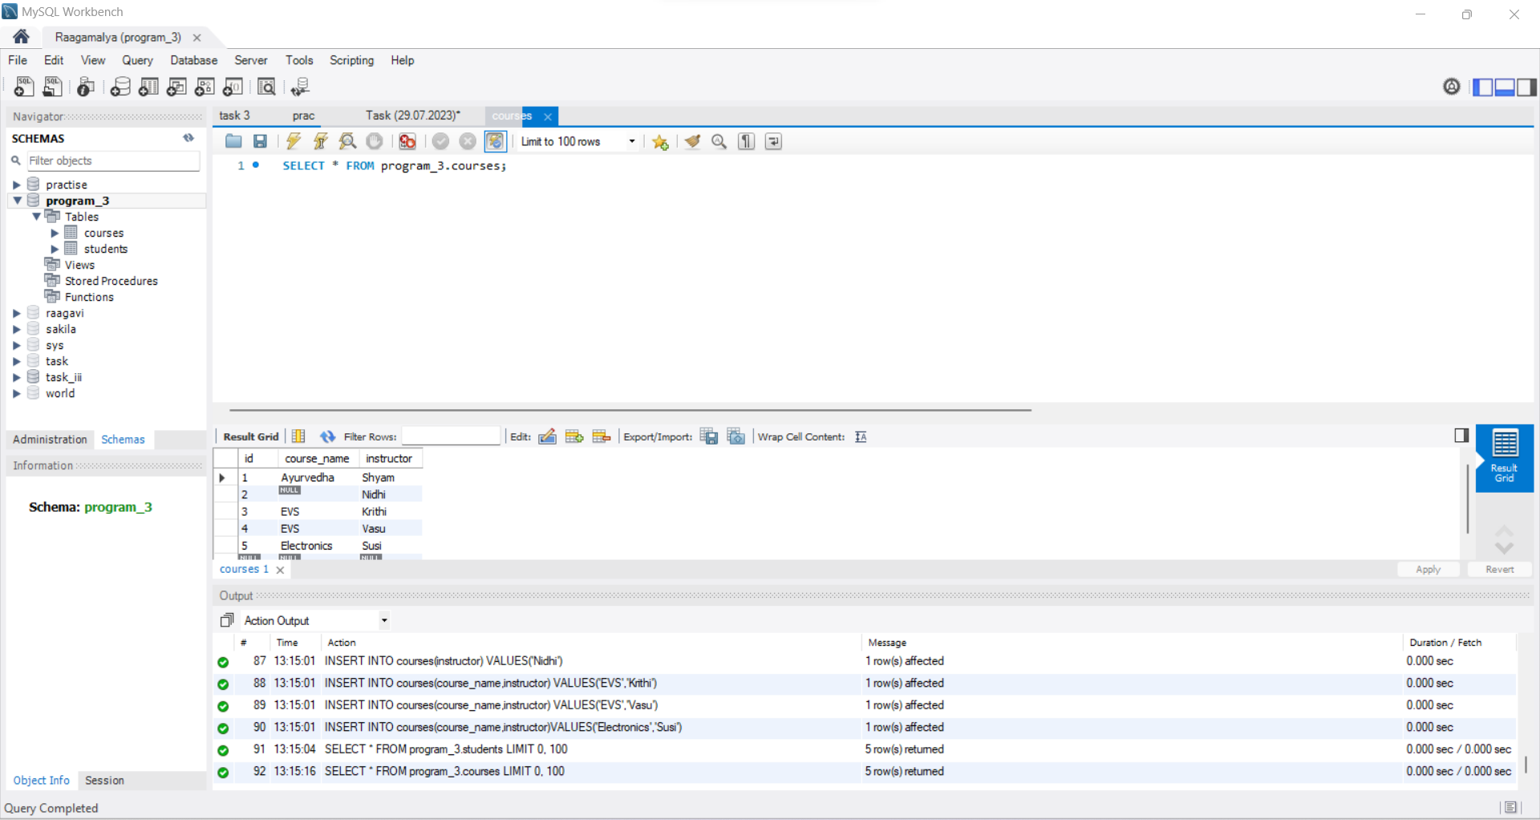

10) Write a query to retrieve all courses and their corresponding instructors.

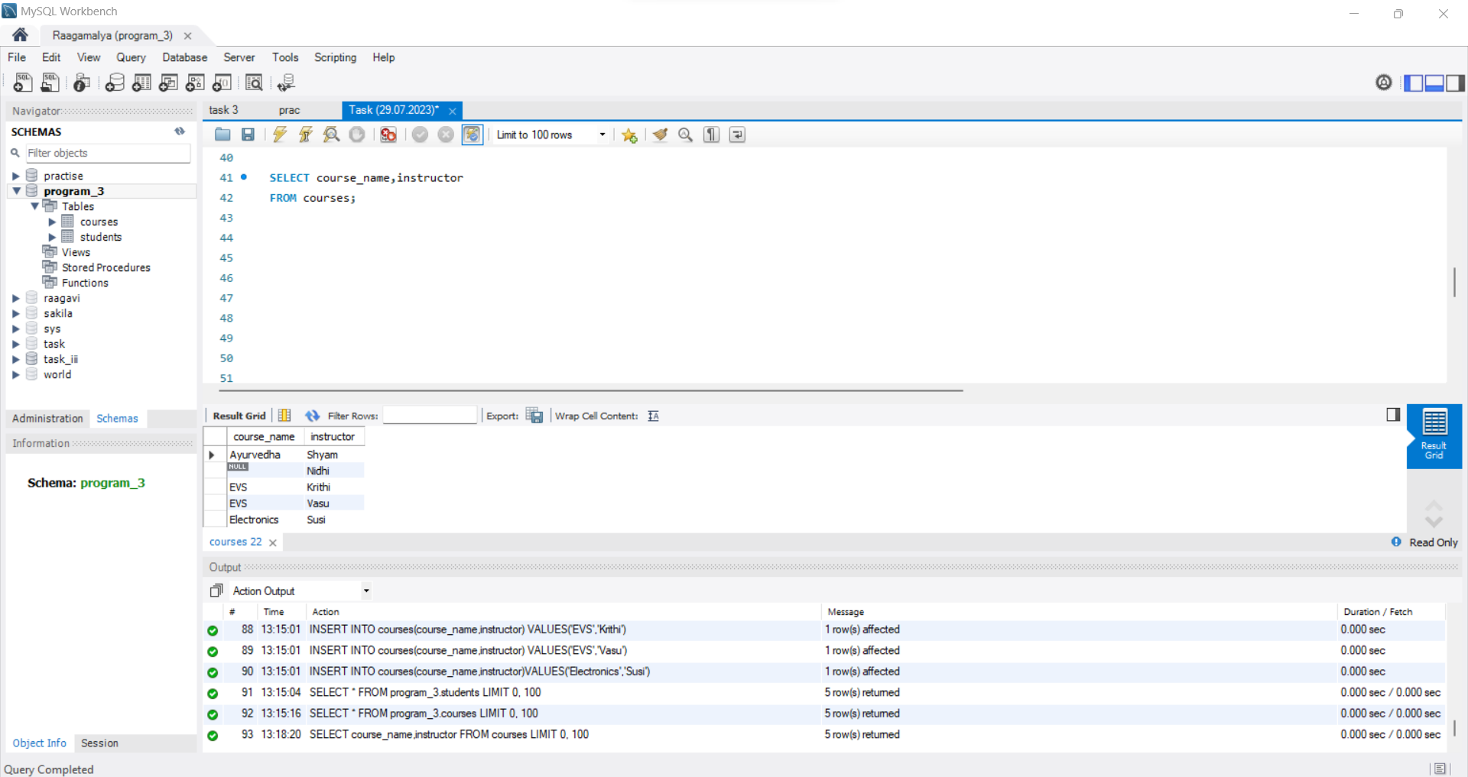

11) Write a query to retrieve students who have enrolled in any course.

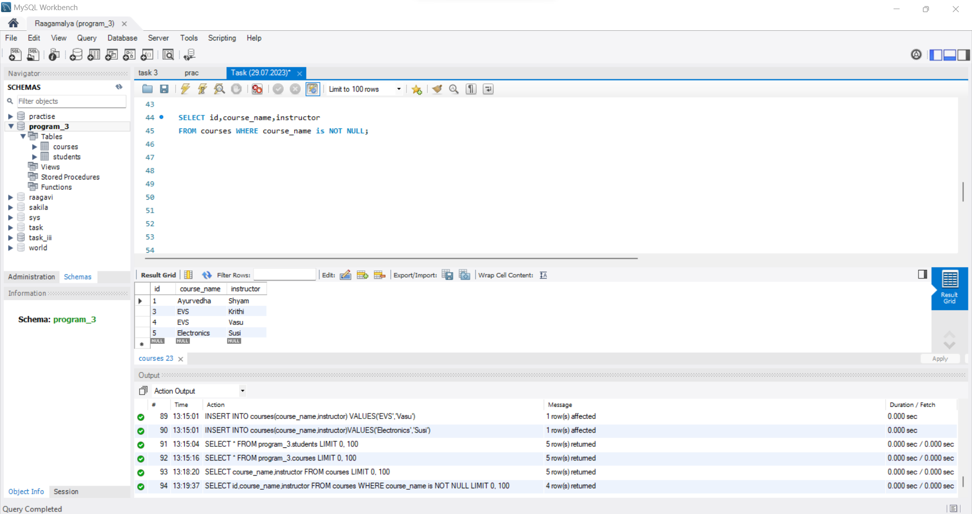

12) Write a query to retrieve the count of students in each course.

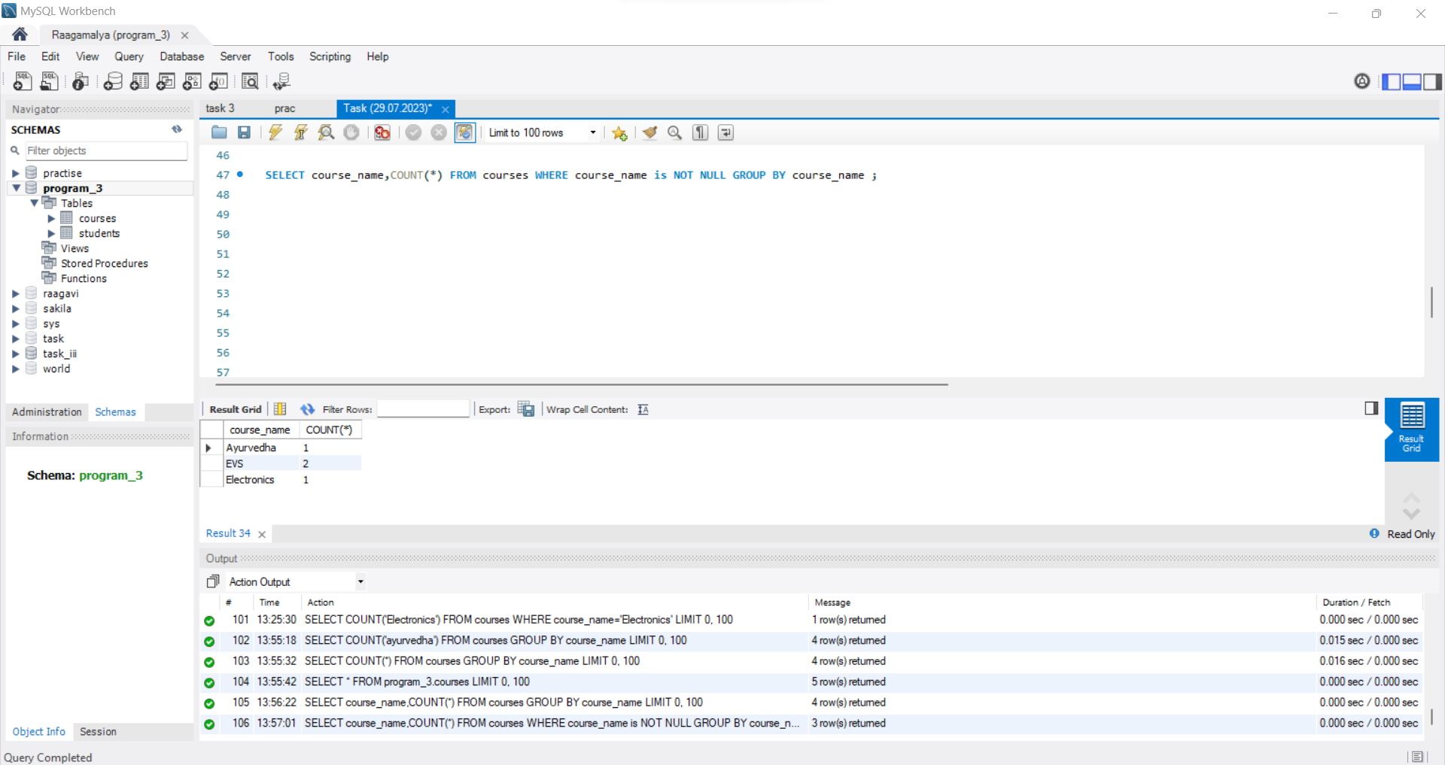

13) Write a query to update the age of a student with a specific email address.

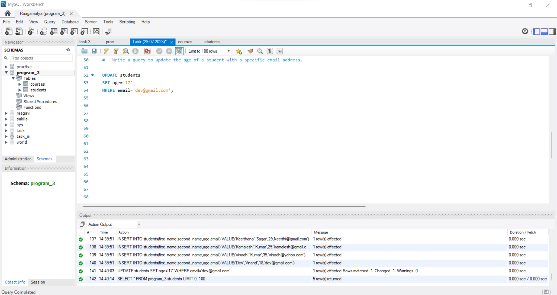

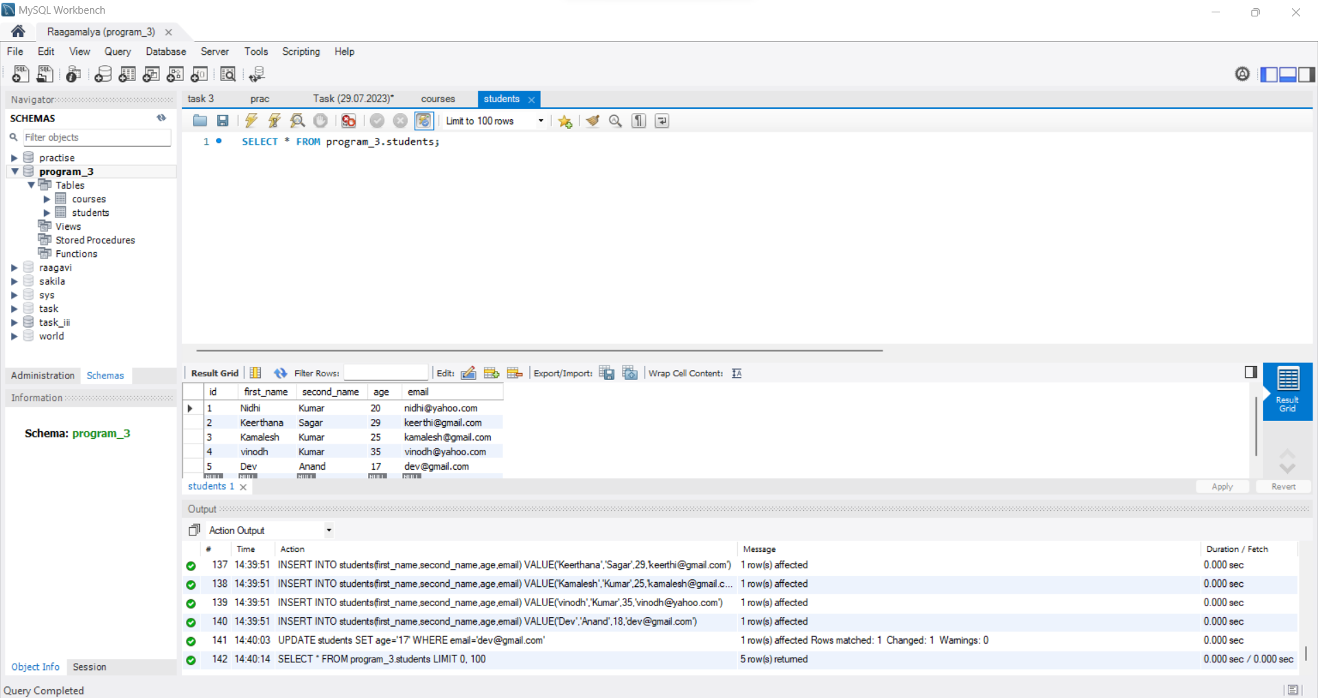

14) Write a query to delete all students who are below 18 years old.

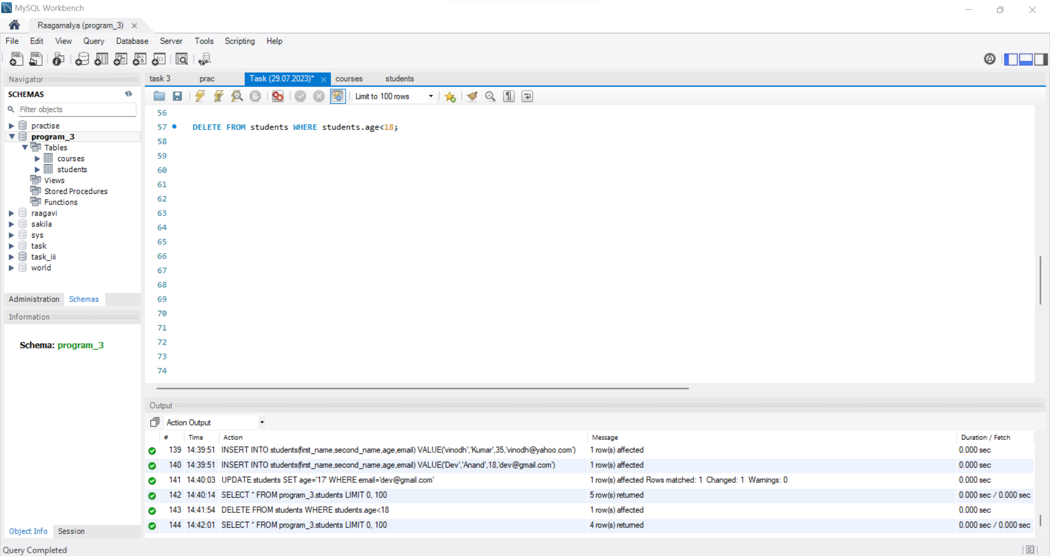

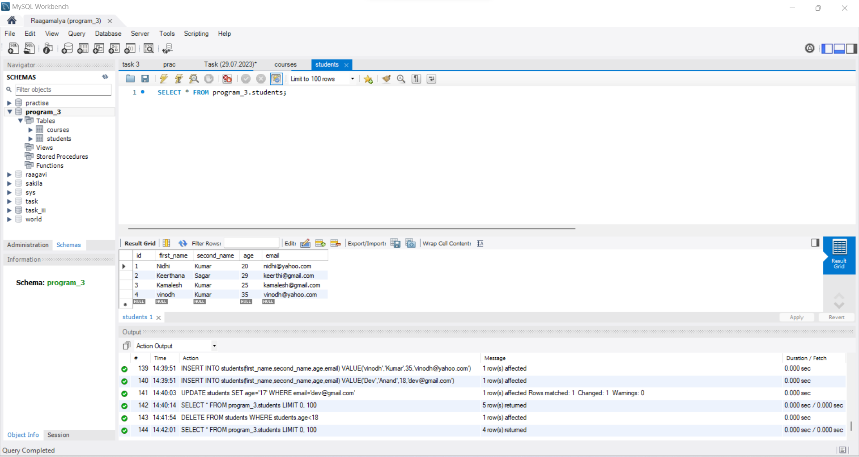

15) Write a query to find the names of students who have not enrolled in any course.

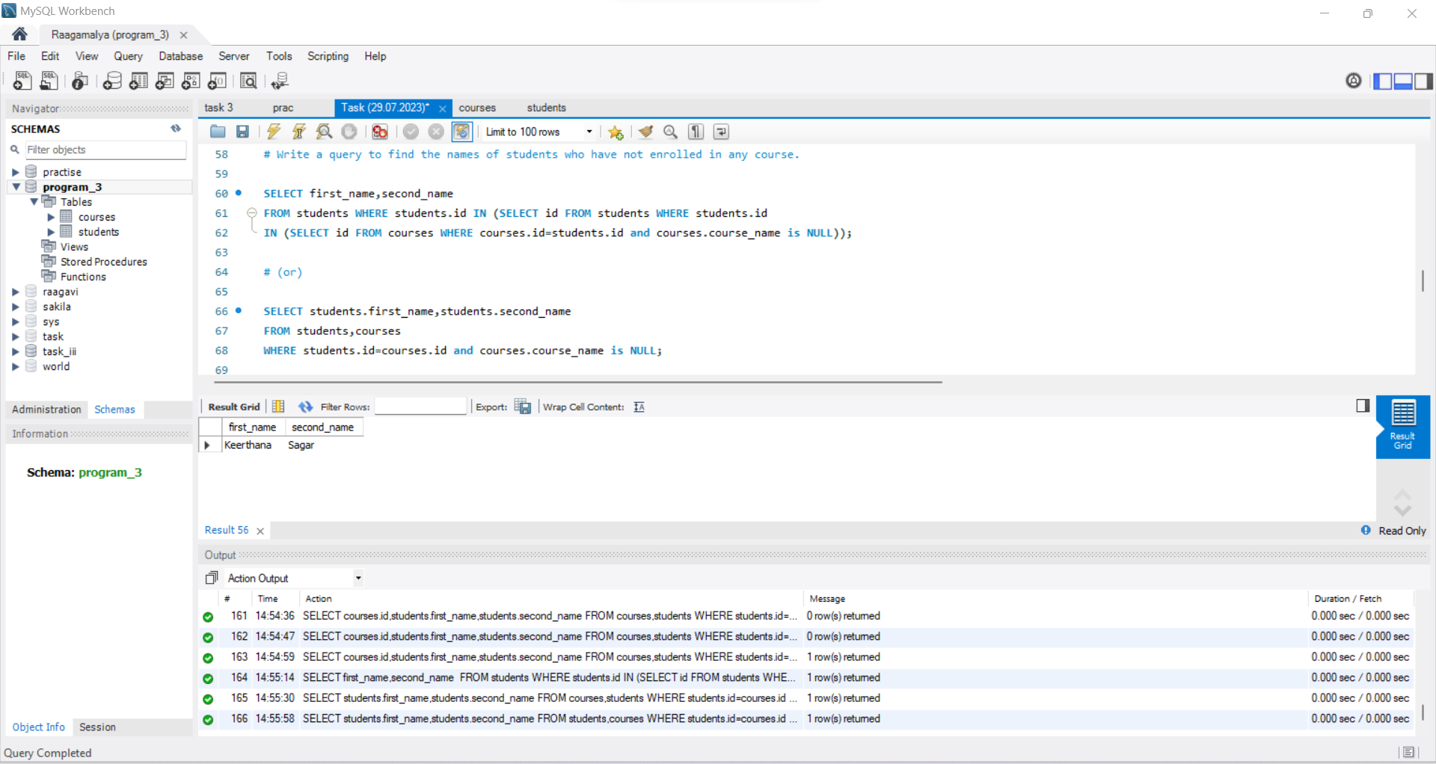

16) Write a query to retrieve the names of students and their course enrolments. If a student is not enrolled in any course, display "Not Enrolled" as the course name.

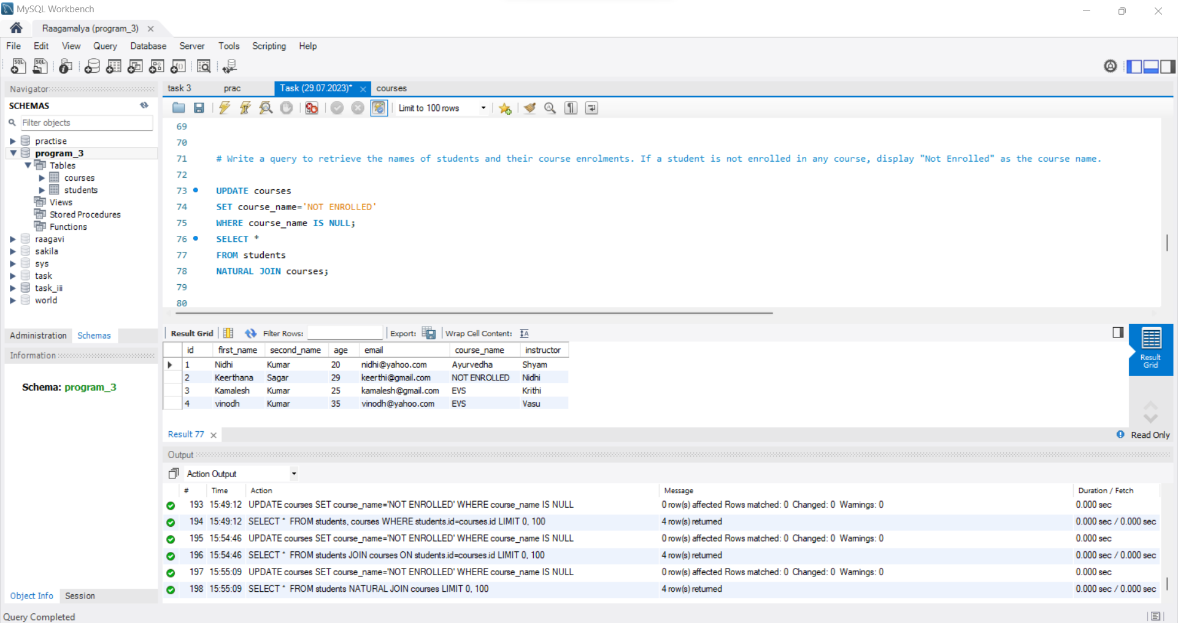

17) Write a query to find the courses that have no students enrolled in them.

18) Write a query to retrieve the courses with more than five students enrolled.

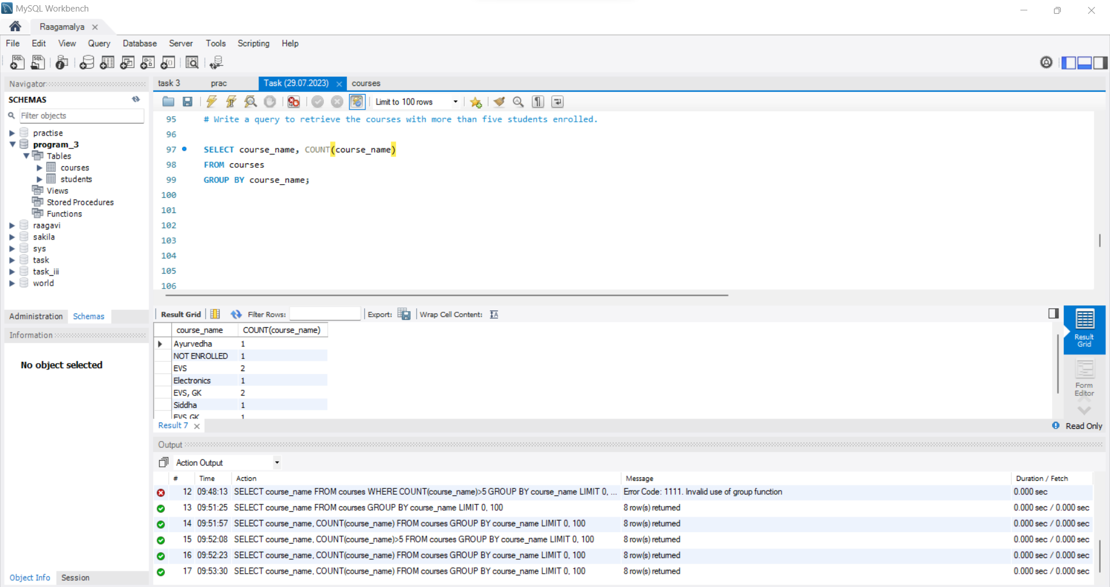

19) Write a query to retrieve the students who have the same first name.

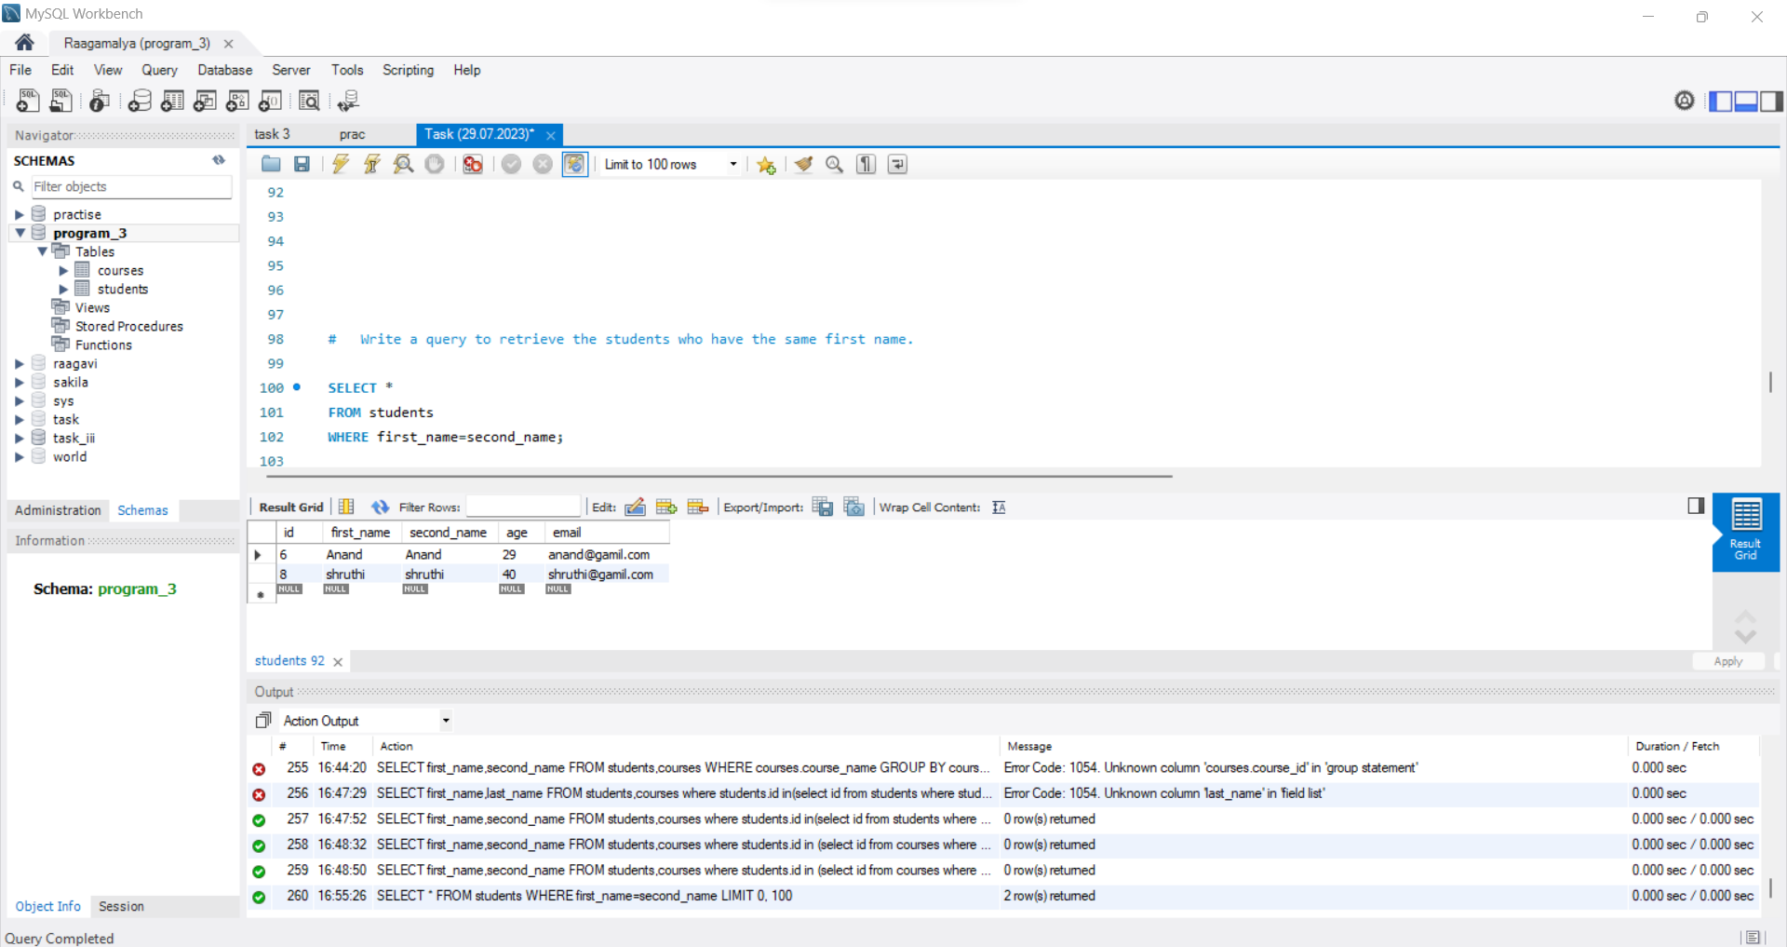

20) Write a query to find the students who have enrolled in more than one course.

